USB Burning Tool update
Step1：Install USB Burning Tool on PC and open it
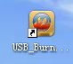
Then you can see this menu:
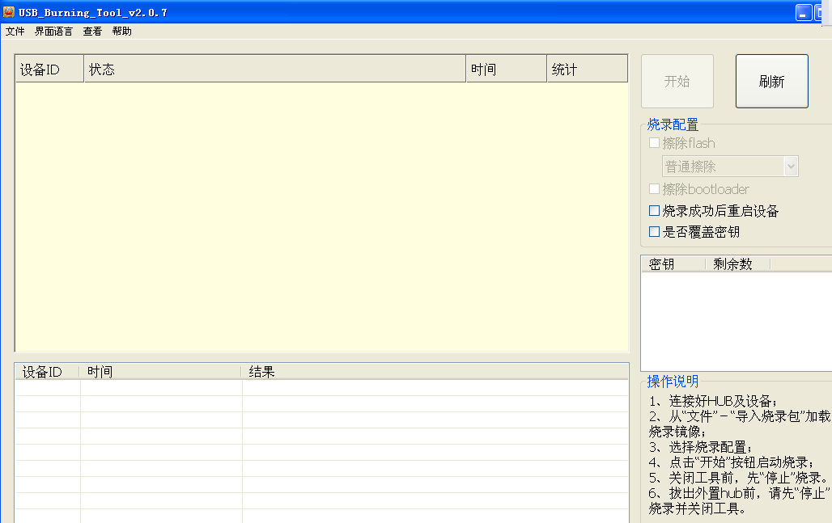
Step2: Click the file – select the firmware
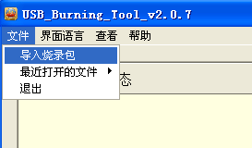
Step3: Click Start
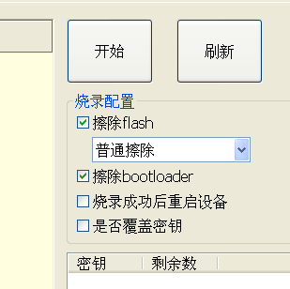
Step4: Press the AV hole for reset, then install USB cable, which is connect to the PC
Note: If not OK, please connect to the other USB port.
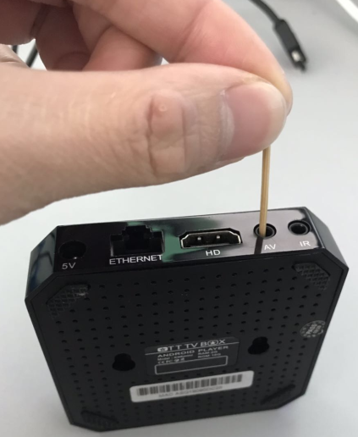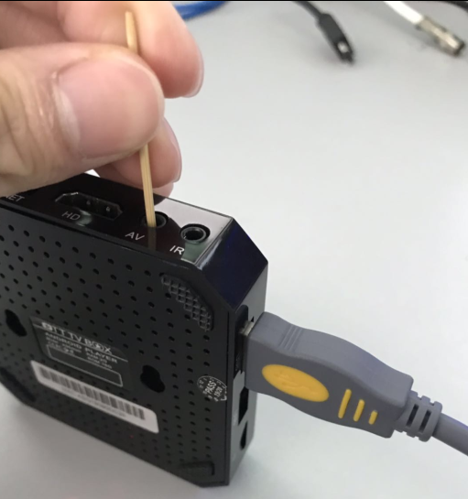
Connect to the PC
Then you can see the below running menu until finished.
